**P. Sai Teja**

**2022EEE2709**

**Simulation of Downlink PD NOMA at arbitrary alpha**



**Performance with alpha at 0.3**

**Obtaining optimal alpha**

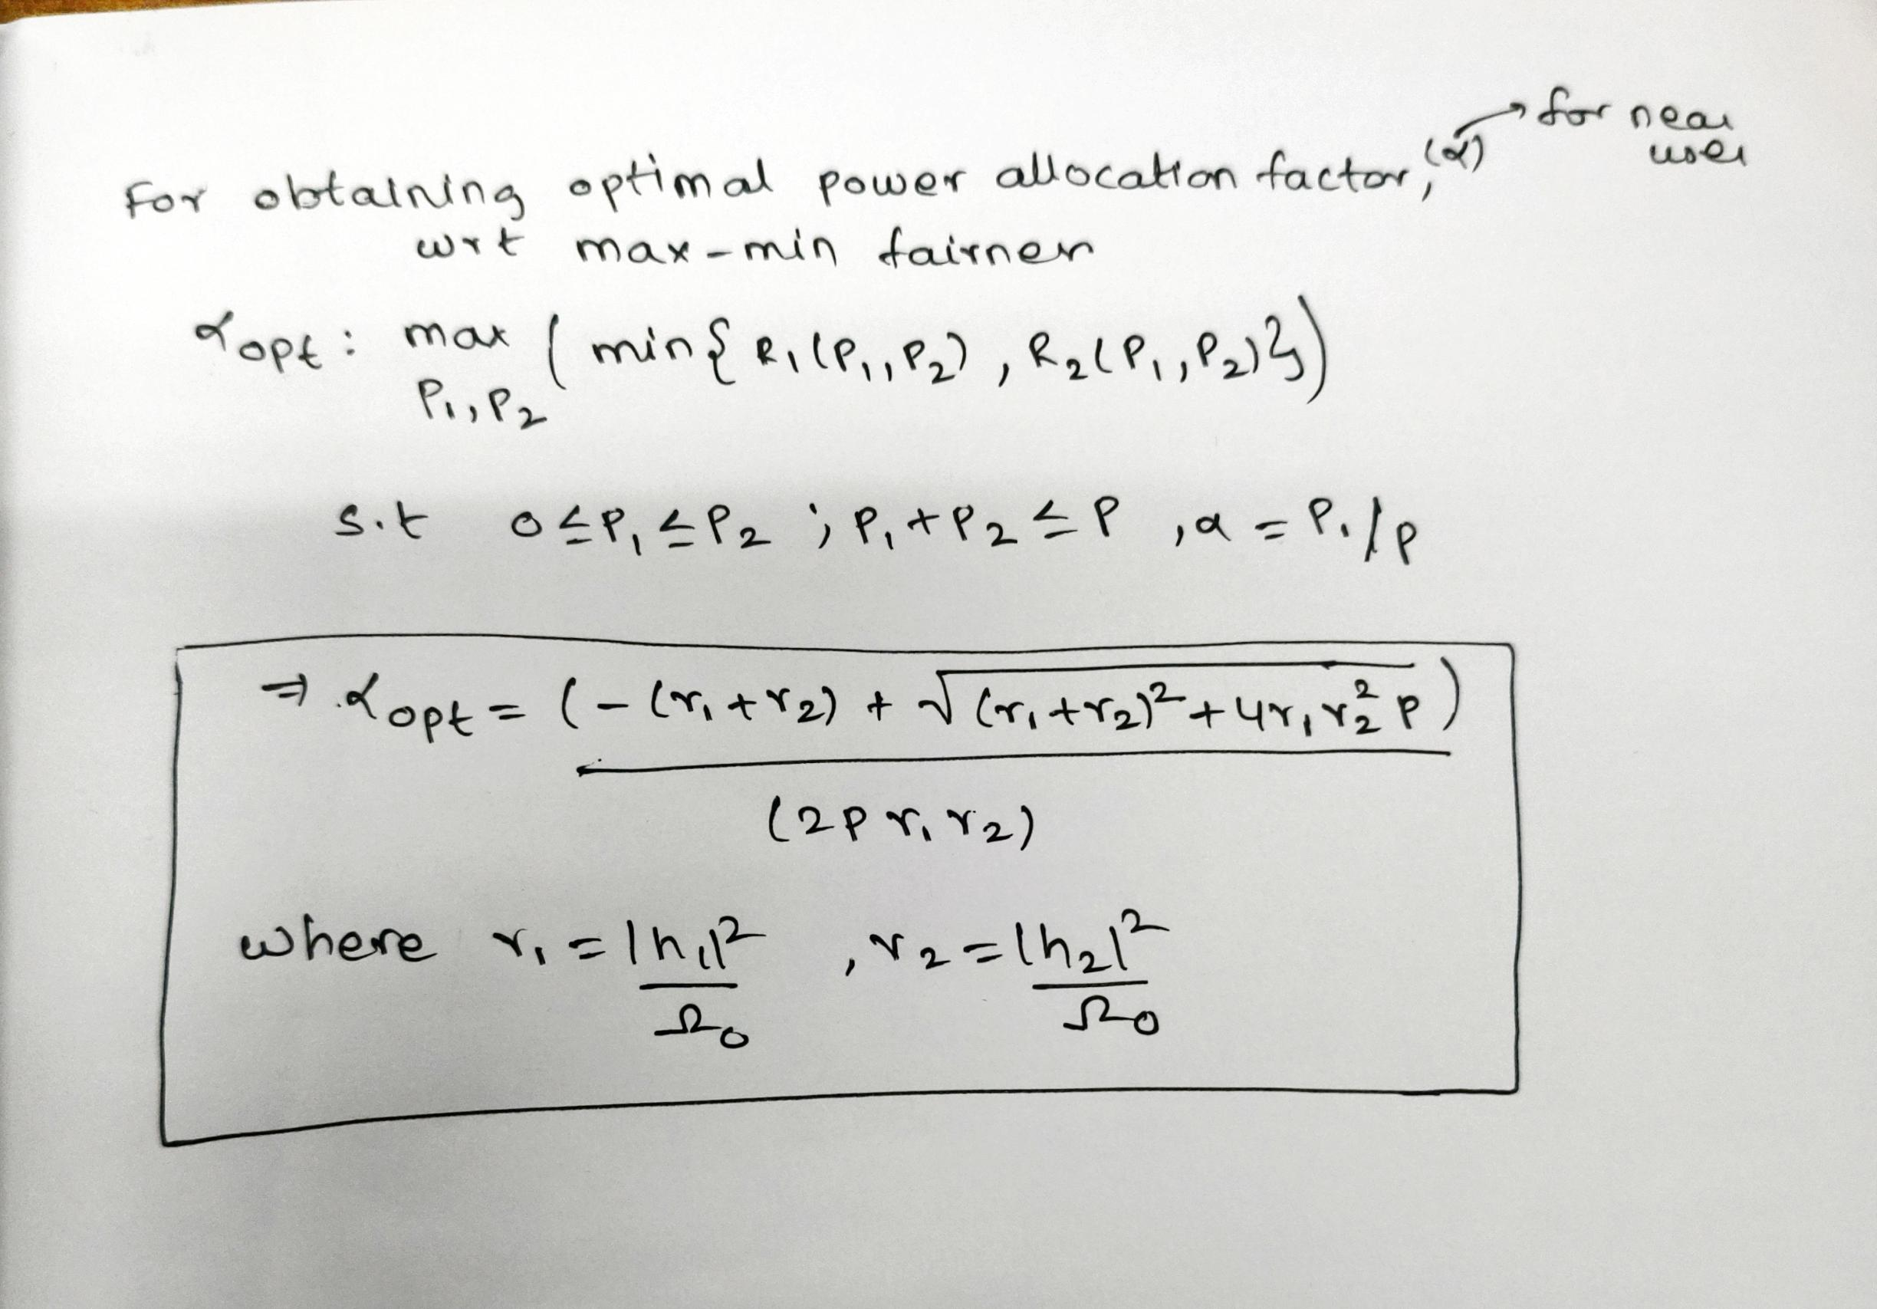

**Simulation of Downlink PD NOMA at optimal alpha**



**Performance with optimal alpha**

**Performance comparison between optimal alpha and alpha at 0.3**

